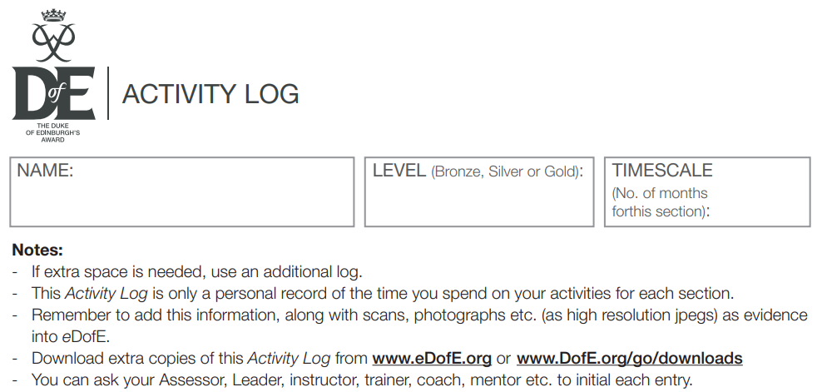

|  |  |  |  |
| --- | --- | --- | --- |
| **Date** | **What you did** | **Hours** | **Initials** |
|  |  |  |  |
|  |  |  |  |
|  |  |  |  |
|  |  |  |  |
|  |  |  |  |
|  |  |  |  |
|  |  |  |  |
|  |  |  |  |
|  |  |  |  |
|  |  |  |  |
|  |  |  |  |
|  |  |  |  |
|  |  |  |  |
|  |  |  |  |
|  |  |  |  |
|  |  |  |  |
|  |  |  |  |